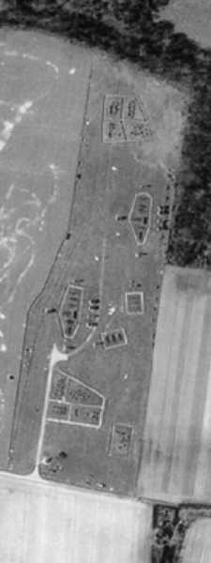
On Saturday 14th January, Arborfield Local History Society presented a book on WWII decoy sites to Wokingham Library. This book, “Fields of Deception”, describes the amazing top-secret work carried out by film companies to deceive the enemy into thinking that they had hit their intended target. In fact, the decoy sites were a few miles away, in open country.

This whole operation was so top secret that it was only declassified in recent years, when English Heritage commissioned “Fields of Deception” to tell the full story before all of the sites were forgotten.

Arborfield had its own decoy site, which fortunately was never set alight because Reading was spared major overnight bombing raids. However, similar sites around Bristol were highly effective in drawing the bombers to unload their deadly cargo away from housing or industry. The Local History Society has included the story on its own web site (www.arborfieldhistory.org.uk), and has now been given permission to show an aerial photo covering the area, showing the elaborate special effects with great clarity.
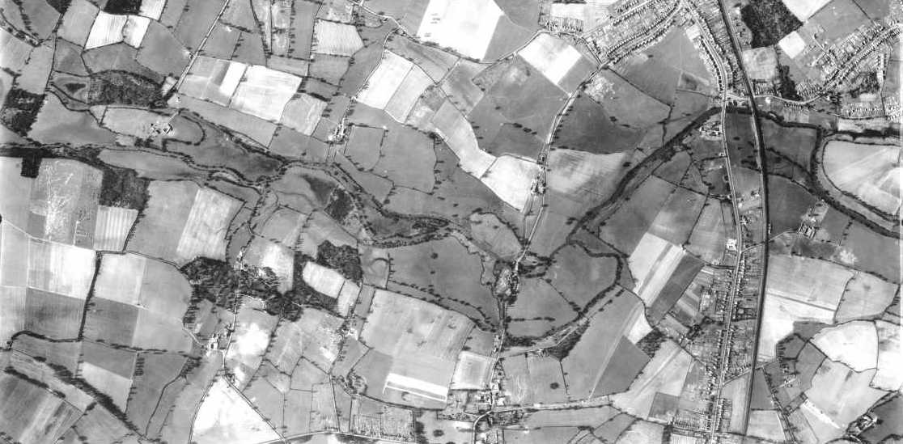

The photo was taken by the USAAF on 8th March 1944, and shows not only the decoy site, but also most of Winnersh and the edges of Earley and Woodley. It’s so detailed that you can see the vegetable patches in the back gardens of people ‘digging for victory’. The web pages super-impose the modern roads and housing on the original photo. Almost half of the fields in the picture are now covered in concrete or houses.

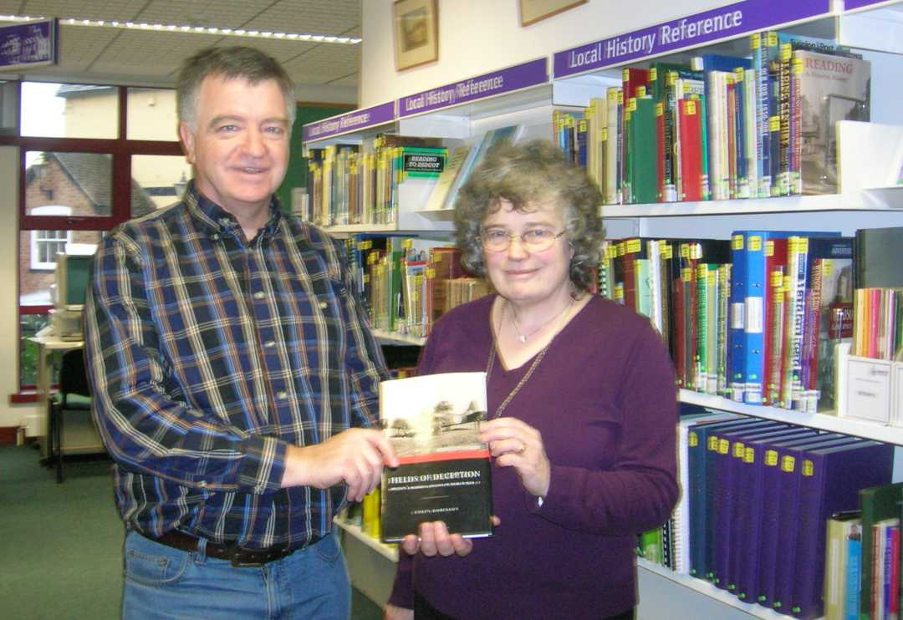
Steve Bacon presented the book to Carol Carson, Local Studies Librarian at Wokingham Library so that anyone interested could get the full story.

Further details from:

Arborfield Local History Society
45 Melrose Gardens
Arborfield
Berkshire
RG2 9PY
Tel. (mobile) 07749 215741
(evg.) 0118 976 0961

e-mail: stephen_paul_bacon@hotmail.com

